**ER DIAGRAM OF HOSPITAL**

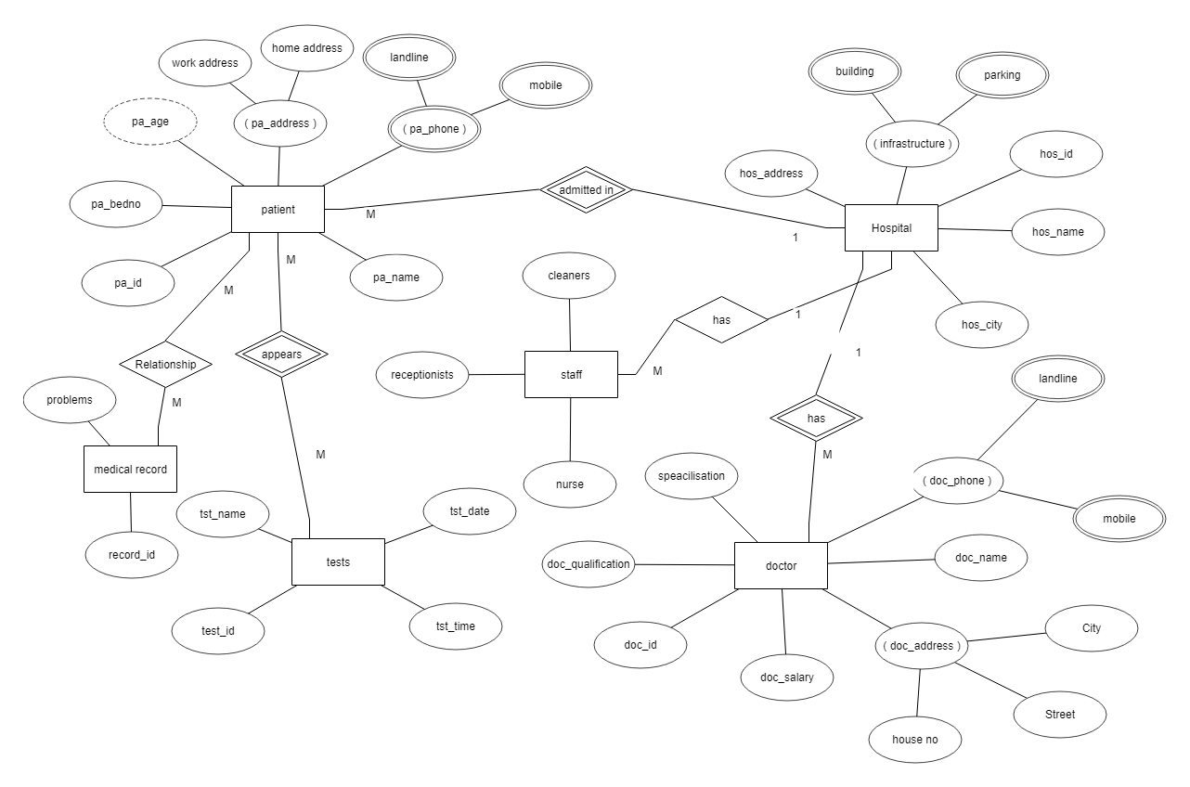

**Entities**:

Hospital

Doctor

Patient

Tests

Staff

Medical Record

**Attributes: 1. Hospital:**

**Hospital address**

**Hospital id**

**Hospital name**

**Hospital city**

**Hospital infrastructure (composite attribute)**

**Building (sub attribute)**

**Parking (sub attribute)**

**2.Doctor:**

**Doctor name**

**Doctor id**

**Doctor salary**

**Doctor qualifications**

**Doctor specialisation**

**Doctor phone (composite attribute)**

**Landline**

**Mobile**

**Doctor address (composite attribute)**

**House no (sub attribute)**

**Street (sub attribute)**

**City (sub attribute)**

**3.Patient**

**Name**

**Address (composite attribute)**

**Work address (sub attribute)**

**Home address (sub attributes)**

**Age (derived attributes)**

**Patient id**

**Patient phone (composite attribute)**

**Landline (sub attribute)**

**Mobile (sub attribute)**

**4.Staff**

**Nurse**

**Receptionist**

**Cleaner**

**5.Tests**

Name

Date

Time

Test id

**6.Medical report**

Problems

Record